1)**Cume_dist()**

The PostgreSQL **cume_dist()** function returns the cumulative distribution of the current row, that is, the ratio of the number of rows from the first row to the last row with the same value as the current row in the total number of rows in the partition.

The PostgreSQL **cume_dist()** function is often used to display the highest or lowest percentage of records in a recordset. For example, the best 5% of students in this exam, etc.

**cume_dist() Syntax**

cume_dist()

OVER (

[PARTITION BY partition_column_list]

[ORDER BY order_column_list]

)

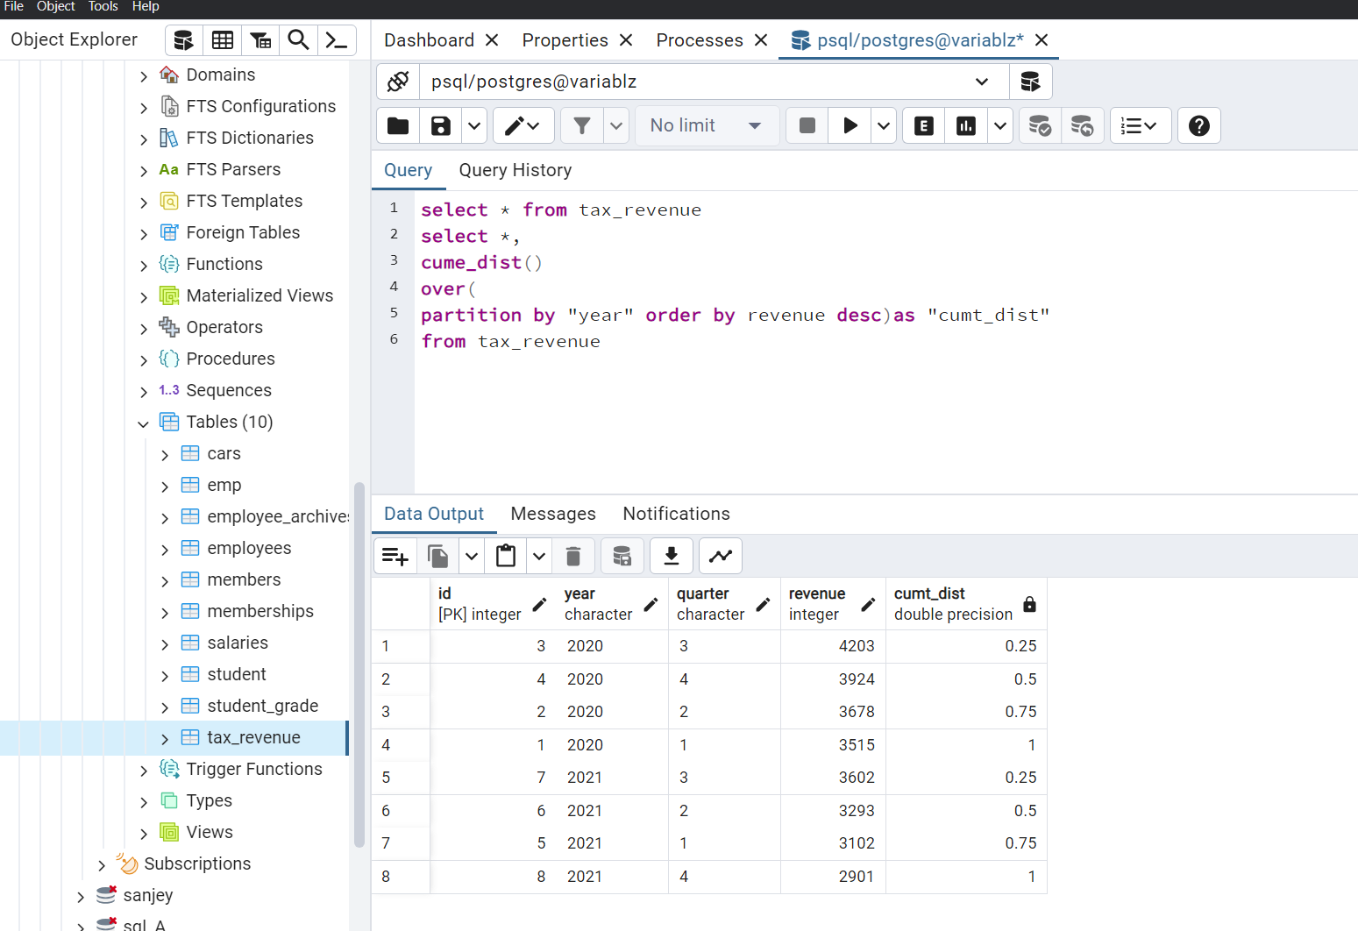

Percentile_dist():

PERCENTILE_DISC**:** This function returns an actual value from the dataset that corresponds to the requested percentile. It doesn’t interpolate; instead, it picks an existing value. The syntax is:

**SQL**

SELECT PERCENTILE_DISC(0.50) WITHIN GROUP (ORDER BY column_name) FROM table_name;

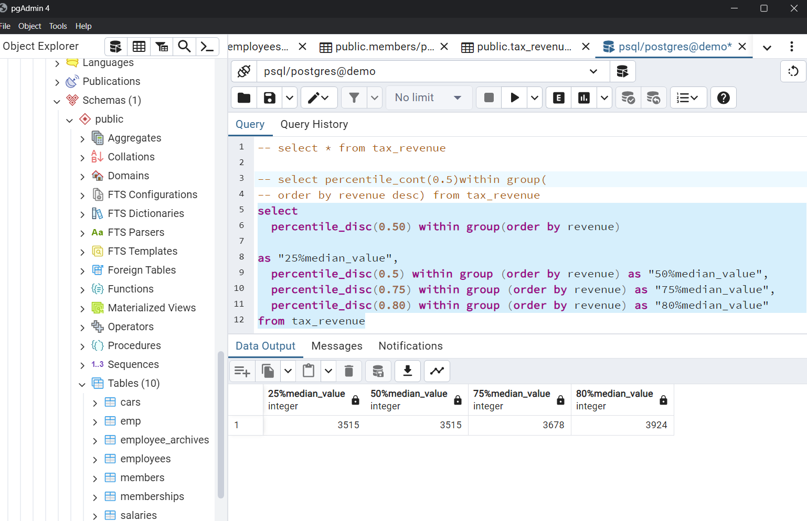

Percentile_const():

PERCENTILE_CONT**:** This function returns a value that is interpolated between the data points. It’s useful when you want to find a percentile within a continuous distribution. The syntax is as follows:

**SQL**

SELECT PERCENTILE_CONT(0.50) WITHIN GROUP (ORDER BY column_name) FROM table_name;

